1. Please download and install the Arduino editor yourself and configure it into ESP32 development mode, and then set the board options.
2. 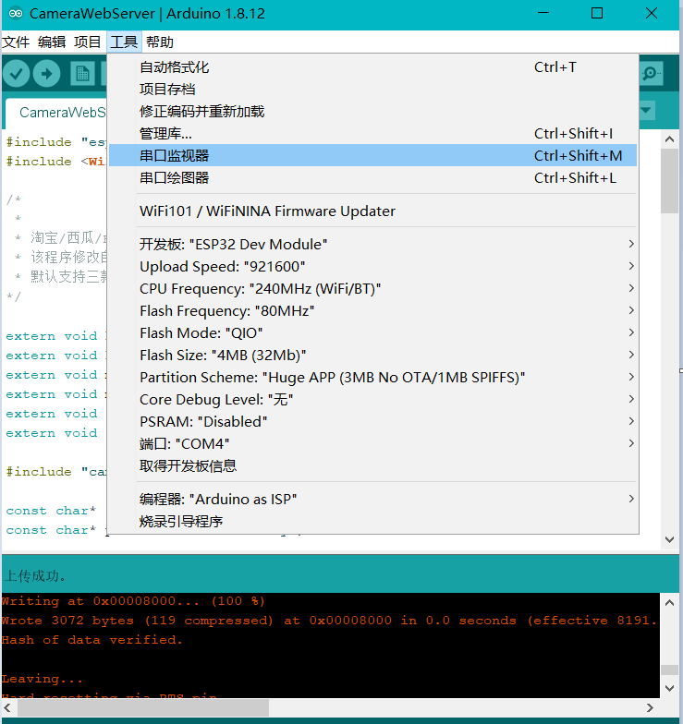

1. Connect the data cable to download the program. Before downloading, please change the wifi name and password in the program to one you can use (it must be connected to the same one as your mobile phone or computer), and then download the program.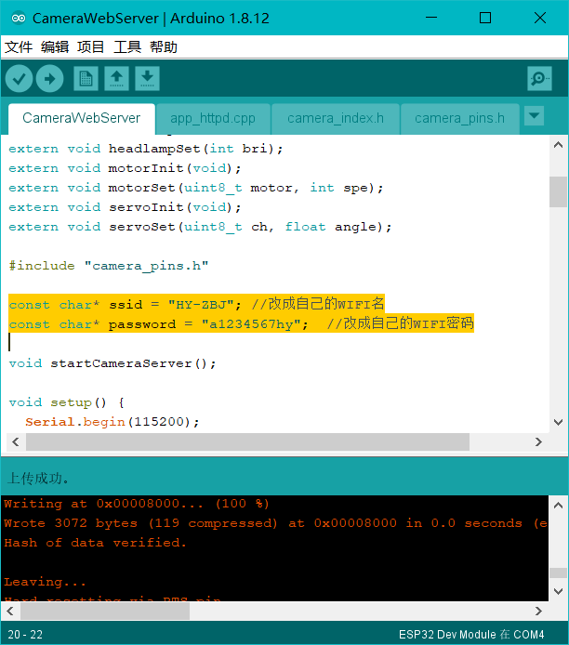

1. Open the serial monitor, restart the robot, and observe the output information. The following indicates that the wifi connection is successful. Enter the URL in the last line into the browser.
2. 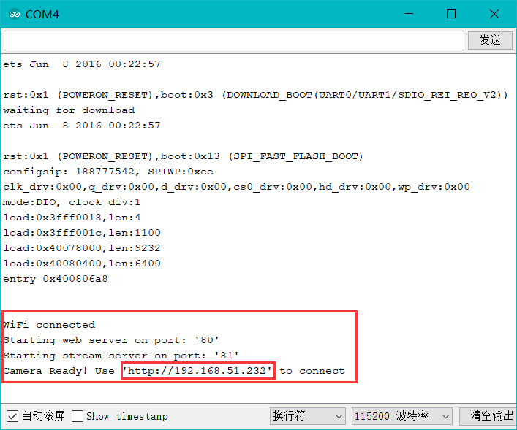
3. Then you can control the robot through the web page (if the robot does not move, try adjusting the speed).
4. 